Integrated Scheduling and Preventive Maintenance Optimization for Green Intelligent Flexible Job Shop Using Machine Learning
Shuran Qian†  Institute of Data and Information,  Tsinghua University,  Beijing, China  qiansr24@mails.tsinghua.edu.cn | Hao Yin†  Institute of Data and Information,  Tsinghua University,  Beijing, China  yinh24@mails.tsinghua.edu.cn |  | Yichen Wang  Institute of Data and Information,  Tsinghua University,  Beijing, China  wang-yc22@mails.tsinghua.edu.cn
Aria Sadewa  Institute of Data and Information,  Tsinghua University,  Beijing, China  Zh-cai24@mails.tsinghua.edu.cn |  | Mingyao Qi*  Institute of Data and Information,  Tsinghua University,  Beijing, China  qimy@sz.tsinghua.edu.cn

Abstract—This paper addresses an integrated job shop scheduling and preventive maintenance optimization problem for green and intelligent manufacturing systems. The proposed model leverages data-driven and AI-based methods to integrate operation-machine assignment, sequencing, machine health management, preventive maintenance, and carbon emission regulation within an intelligent scheduling framework. Key parameters are estimated from real shop-floor data using supervised machine learning, enabling adaptive optimization in dynamic production environments. The objective is to minimize total cost, including makespan, emissions, maintenance, and tardiness, while ensuring reliability and low-carbon compliance. A tailored solution method is developed, with both a Genetic Algorithm (GA) and Gurobi implemented for comparative analysis. Extensive numerical experiments on benchmark instances demonstrate the effectiveness of the proposed approach and provide insights into balancing efficiency, sustainability, and equipment reliability in intelligent manufacturing.
Keywords- Machine Learning; Flexible Job Shop Scheduling; Preventive Maintenance; Green Intelligent Manufacturing; Mixed-Integer Programming

Introduction
† These authors contributed equally to this work.
* Corresponding author: qimy@sz.tsinghua.edu.cn
Modern manufacturing job shops are challenged to maximize production efficiency while also meeting increasingly strict environmental regulations and equipment reliability requirements. The rise of green, low-carbon policies has driven the development of scheduling methods that must coordinate productivity, energy usage, and preventive maintenance. Traditional scheduling models typically overlook machine degradation and carbon emissions, even though, in practice, equipment health degrades as jobs are processed—leading to a higher risk of failures and unplanned downtime. Moreover, regulatory limits on carbon emissions during specific low-carbon periods further complicate scheduling decisions.
To address these issues, researchers have extensively studied the classical Job Shop Scheduling Problem (JSP), which serves as a foundational model in manufacturing systems and operations research. Over the decades, a large body of literature has explored optimal scheduling theory and algorithms, supported by a suite of benchmark instances and evaluation criteria that provide a common ground for algorithm development and comparative analysis [1,2,3]. To enhance adaptability for modern, high-mix and low-volume production, the Flexible Job Shop Scheduling Problem (FJSP) was introduced, enabling each operation to be assigned flexibly to any eligible machine and thereby increasing robustness and resource utilization [4,5].
With the growing emphasis on sustainability, recent research has incorporated energy consumption and carbon emission objectives into FJSP models. For example, Luan et al. [6] proposed an enhanced NSGA-II for multi-objective energy-saving flexible job shop scheduling, explicitly modeling the trade-off between production efficiency and energy usage. Pan et al. [7] developed a bi-population evolutionary algorithm with feedback mechanisms for energy-efficient fuzzy FJSP, considering uncertainties in practice. Furthermore, Benedikt et al. [8] introduced a green scheduling approach that optimizes energy cost by integrating time-of-use electricity tariffs and machine states.
Despite these advances, most studies still focus mainly on minimizing energy or emissions, with relatively few considering the integrated effects of machine deterioration, preventive maintenance, and time-varying carbon constraints. In real-world production, the dynamic interplay among equipment health, maintenance actions, and emission limits increases both the complexity and uncertainty of scheduling. There is, therefore, a clear need for holistic models that simultaneously optimize production, equipment reliability, and environmental performance.
In response, this paper proposes an integrated scheduling and preventive maintenance optimization model for green flexible job shops, with key parameters estimated from historical production and maintenance data using machine learning techniques. The model aims to jointly minimize makespan, carbon emissions, maintenance costs, and job tardiness, thereby achieving a coordinated balance between efficiency, sustainability, and equipment reliability. The effectiveness of the proposed approach is validated through numerical experiments and comparative analysis, offering new insights for production scheduling and maintenance management in green manufacturing environments.

Formulation

Problem Description
We address a joint scheduling and preventive maintenance problem in a flexible job shop with machine health and carbon emission constraints. Multiple jobs, each with sequential operations, are assigned to parallel machines under precedence and capacity limits. Machine health declines as operations proceed, and preventive maintenance can restore it but incurs costs and downtime. Maintenance must be triggered if machine health falls below a threshold to avoid breakdowns. Additionally, during low-carbon periods, total emissions from processing must remain within specified limits. The goal is to optimize both production and maintenance schedules to minimize makespan, carbon emissions, maintenance costs, and job tardiness, explicitly balancing efficiency, sustainability, and equipment reliability.

Mathematical Model
The main sets, parameters, and decision variables used in the model are summarized in Table 1.
Table 1 Summary of Sets, Parameters, and Variables
Symbol | Definition
Sets
$$J=1,2,…,n$$ | Set of jobs
$$M=1,2,…,m$$ | Set of machines
$$O_{i}=1,2,…,n_{i}$$ | Set of operations for job $i$
$$O=\left(i,j\right):i∈J,,j=1,…,n_{i}$$ | Set of all operations
$$M_{ij}$$ | Set of eligible machines for operation $j$ of job $i$
$$T=1,2,…,H$$ | Set of discrete time periods
$$T_{low}⊆T$$ | Set of low-carbon emission time periods
$$T_{normal}=T∖T_{low}$$ | Set of normal emission time periods
Parameters
$$n_{i}$$ | Number of operations in job $i$
$$p_{ijk}$$ | Processing time of operation $j$ of job $i$ on machine $k$
$$e_{ijk}$$ | Unit carbon emission of operation $j$ of job $i$ on machine $k$
$$d_{i}$$ | Due date of job $i$
$$h_{k}^{init}$$ | Initial health value of machine $k$
$$h_{k}^{min}$$ | Health threshold of machine $k$
$$h_{k}^{max}$$ | Maximum health value of machine $k$
$$d_{k}$$ | Health degradation rate of machine $k$ per time slot
$$r_{k}$$ | Health recovery amount for machine $k$ per maintenance
$$t_{k}^{repair}$$ | Maintenance duration for machine $k$
$$α, β, γ, δ$$ | Weight coefficients in objective
$$EC_{t}^{limit}$$ | Carbon emission limit at time $t$ (low-carbon periods)
$$λ_{i}$$ | Tardiness penalty coefficient for job $i$
$$M$$ | A sufficiently large constant
Decision Variables
$$Z$$ | Objective function value
$$x_{ijkt}$$ | $1 if operation j of job i$starts on $k$  $at time t,$ $0$ $otherwise$
$$ms_{kt}$$ | $$1 if maintenance starts for machine k$$  $at time t,$ $0$ $otherwise$
$$m_{kt}$$ | $$1 if machine k is under maintenance$$  $at time t,$ $0$ $otherwise$
$$y_{kt}$$ | $1 if machine k is processing$ $at time t,$ $0$ $otherwise$
$$h_{kt}$$ | Health value of machine $k$ at time $t$  $$(t∈0∪T)$$
$$C_{i}$$ | Completion time of job $i$
$$C_{max}$$ | Makespan
$$T_{i}$$ | Tardiness of job $i$
$$EC_{t}$$ | Total carbon emission at time $t$

 | $$Z=αC_{max}+β\sum_{t∈T}{EC_{t}}+γ\sum_{k∈M}{\sum_{t∈T}{ms_{kt}}}+δ\sum_{i∈J}{λ_{i}T_{i}}$$ | (1)
 | $$\sum_{k∈M_{ij}}{\sum_{t∈T}{x_{ijkt}}}=1, ∀i∈J, j∈O_{i}$$ | (2)
 | $$\sum_{k∈M_{ij}}{\sum_{t∈T}{\left(t+p_{ijk}\right)}} x_{ijkt}$$  $$≤\sum_{k∈M_{i,j+1}}{\sum_{t∈T}{t}} x_{i,j+1,kt}, ∀i∈J, j∈O_{i}∖\{n_{i}\}$$ | (3)
 | $$y_{kt}+m_{kt}≤1, ∀ k∈M, t∈T$$ | (4)
 | $$y_{kt}=\sum_{\left(i,j\right):k∈M_{ij}}{\sum_{τ:τ≤t≤τ+p_{ijk}-1}{x_{ijkτ}}}, ∀k∈M, t∈T$$ | (5)
 | $$C_{i}≥\sum_{k∈M_{i,n_{i}}}{\sum_{t∈T}{\left(t+p_{i,n_{i},k}\right)}} x_{i,n_{i},kt}, ∀i∈J$$ | (6)
 | $$C_{max}≥C_{i}, ∀i∈J$$ | (7)
 | $$T_{i}≥C_{i}-d_{i}, T_{i}≥0, ∀i∈J$$ | (8)
 | $$h_{k0}=h_{k}^{init}, ∀k∈M$$ | (9)
 | $$0≤h_{kt}≤h_{k}^{max}, ∀k∈M, t∈\{0\}∪T$$ | (10)
 | $$h_{kt}=h_{k,t-1}-d_{k}y_{kt}+r_{k}ms_{kt},$$  $$∀k∈M, t∈T, t≥1$$ | (11)
 | $$m_{kτ}=\sum_{s=\max\left(1,τ-t_{k}^{repair}+1\right)}^{τ}{ms_{ks}},$$  $$∀k∈M, τ∈T$$ | (12)
 | $$ms_{kt}≥\max\left(0,h_{k}^{min}-h_{k,t-1}\right), ∀k∈M, t∈T$$ | (13)
 | $$EC_{t}=\sum_{k∈M}{\sum_{\left(i,j\right):k∈M_{ij}}{e_{ijk}\sum_{τ:τ≤t≤τ+p_{ijk}-1}{x_{ijkτ}}}},$$  $$∀t ∈T$$ | (14)
 | $$EC_{t}≤EC_{t}^{limit}, ∀t∈T_{low}$$ | (15)
 | $$x_{ijkt}=0, ∀i∈J, j∈O_{i}, k∉M_{ij}, t∈T$$ | (16)
 | $$x_{ijkt}, ms_{kt}, m_{kt}, y_{kt}∈\{0,1\};$$  $$h_{kt}, C_{i}, C_{max}, T_{i}, EC_{t}≥0$$ | (17)
The objective function (1) minimizes a weighted sum of makespan, total carbon emissions, maintenance costs (counted by maintenance initiations), and job tardiness penalties. Constraints (2)–(6) jointly ensure feasible assignment and sequencing of operations: each operation is assigned exactly once to an eligible machine and unique start time, and all technological precedence relationships within jobs are maintained. Constraints (4) and (5) ensure that each machine can be either processing or under maintenance at any time, but not both, and define the processing state according to ongoing operations. Job completion times and the makespan are captured by constraints (6) and (7), while tardiness is determined by (8). Machine health dynamics are modeled through constraints (9)–(13), which set initial health, maintain health within physical limits, update health values based on degradation and recovery, ensure required maintenance duration, and enforce immediate maintenance if health falls below a threshold. Environmental objectives are addressed by constraints (14) and (15), which compute and regulate total carbon emissions, particularly during low-carbon periods. Finally, constraints (16)–(17) define machine eligibility for each operation and specify the domains of all decision variables.

Algorithm Design

Parameter Estimation Using Machine Learning
Many key parameters—such as machine degradation rates, maintenance recovery, and operation-specific carbon emissions—are difficult to determine in advance and vary across machines and production settings. To estimate these parameters realistically, we use a machine learning approach based on historical manufacturing and maintenance data. We collect comprehensive records, including operation logs, maintenance events, sensor-based health data, and energy or emission measurements. After data cleaning and synchronization, relevant features are extracted for each machine, such as operation type, load, sequence, time since last maintenance, energy use, cumulative workload, and environmental factors.
Regression models are then trained for parameter estimation. The machine degradation rate ($d_{k}$) is obtained by regressing health indices (e.g., vibration, temperature, performance) on cumulative workload or time since last maintenance. Maintenance recovery values ($r_{k}$) are estimated by averaging the observed increase in health following each maintenance event. Unit carbon emission parameters ($e_{ijk}$) are extracted by fitting supervised models to map operation and machine features to observed emission or energy data. All models are validated using cross-validation or hold-out sets to ensure robustness. The resulting parameter estimates are used as direct inputs for the scheduling optimization model. The detailed estimation workflow is summarized in Algorithm 1.
  Algorithm 1. Data-driven Parameter Estimation Workflow
  Input: Historical shop-floor dataset $D$
  Output: Estimated $d_{k}$, $r_{k}$, $e_{ijk}$ for all relevant $k$, $\left(i,j,k\right)$
1:
  For each machine $k$ do
2:
  Extract features and health history from $D$
3:
  Fit regression: health index vs. cumulative workload
4:
  Set $d_{k}$ as the average slope of health decay
5:
  Identify all maintenance events for $k$
6:
  For each maintenance event do
7: | Compute $r_{k}$ as health improvement after maintenance  end
8: | Aggregate $r_{k}$values (mean or median)
9: | For each operation $\left(i,j\right)$ , machine $k$ do
10:
  Collect emission and feature samples
11:
  Fit regression: emissions vs. features
12:
  Set $e_{ijk}$ as mean model prediction
  end
13:
  Return all estimated parameters

Genetic Algorithm
To efficiently solve the integrated green low-carbon flexible job shop scheduling problem, a tailored Genetic Algorithm (GA) is developed. First, an initial population of feasible solutions is generated. In each generation, individuals are evaluated by the objective function, and the fittest are selected for reproduction. New offspring are produced through crossover and mutation operators, with elitism applied to retain the top solutions. This process iterates until a stopping criterion is reached..
Each individual (chromosome) simultaneously encodes a complete production schedule and a preventive maintenance plan. As illustrated in Fig.1, the chromosome is structured as a list of quadruples, where each element specifies the job index, operation index, assigned machine, and starting time, i.e., (j, o, m, s). The sequence of quadruples determines the global operation order, subject to technological precedence and machine eligibility constraints. In parallel, the maintenance plan is represented as a binary matrix, where each entry indicates whether a preventive maintenance activity is scheduled for a given machine at a particular time period. Decoding proceeds by sequentially dispatching operations as specified, ensuring that each operation starts only after its technological predecessors and assigned machine become available, while enforcing that machine availability is interrupted by preventive maintenance according to the maintenance plan.
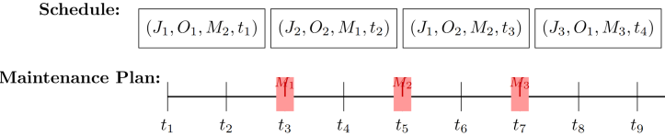
Figure 1 Chromosome encoding for the proposed genetic algorithm.
The initial population is generated by creating feasible individuals based on the encoding scheme. For each individual, operations from all jobs are merged into a global sequence with job order preserved, and each operation is assigned to the earliest available eligible machine while respecting all constraints. Preventive maintenance is inserted whenever machine health is projected to fall below the threshold and the machine is idle, ensuring individual feasibility.
Each individual's fitness is evaluated by the objective function, considering makespan, carbon emissions, maintenance cost, and tardiness penalties. All feasibility constraints are strictly enforced during evaluation. Infeasible individuals are penalized with a large fitness value to promote feasible solutions during selection.
New individuals are generated by applying crossover and mutation to parents selected via tournament selection. The crossover operator adopts the order crossover (OX) mechanism, which preserves the internal operation sequence of each job while recombining job-level scheduling order. Mutation introduces diversity by swapping job orders, reassigning machines for specific operations, or modifying maintenance decisions. After each genetic operation, the schedule and maintenance plan are reconstructed to ensure feasibility. The order crossover procedure is illustrated in Fig.2.
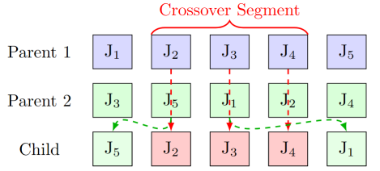
Figure 2 Illustration of the order crossover (OX) procedure.

Numerical experiments

Experimental Setup and Benchmark Instances
All experiments were performed on a Windows 11 PC with an Intel Core i7 processor and 16 GB RAM. The algorithms were implemented in Python 3.12, and Gurobi 11.0 was used for exact optimization. To evaluate the effectiveness and scalability of the proposed method, a diverse set of benchmark instances was selected, covering small, medium, and large-scale cases. Key characteristics of all selected instances are summarized in Table 2. Performance metrics include makespan, total carbon emissions, maintenance cost, tardiness penalty, and computational time. All experimental results are averaged over 10 independent runs to ensure statistical reliability.
Table 2 Summary of benchmark instances
Instance Type | Instance IDs | Jobs | Machines
Small | Fattahi SFJSP (adapted) | 3–5 | 2–5
Medium | MK1, MK2, MK3, MK4, MK5 | 10–15 | 4–8
Large | MK6, MK7, MK8, MK9, MK10 | 10–20 | 10–15

Parameter Settings
All algorithmic and model parameters used in the experiments are summarized in Table 3. Most parameters, including genetic algorithm settings and model weights, were selected based on commonly used values in the literature and preliminary tests. However, several critical parameters—such as the machine degradation rate, maintenance recovery value, and per-operation carbon emission factor—are inherently difficult to specify in advance due to their strong dependence on specific machine types and production environments. To ensure the realism and adaptability of the proposed approach, these parameters were estimated via a data-driven machine learning procedure based on historical operational and maintenance records.
Table 3 Main parameter settings for the proposed optimization algorithms
Parameter | Value | Description / Source
Population size | 500 | Genetic algorithm parameter
Number of generations | 500 | Genetic algorithm parameter
Crossover rate | 0.8 | Genetic algorithm parameter
Mutation rate | 0.2 | Genetic algorithm parameter
Tournament size | 5 | Genetic algorithm parameter
Elitism rate | 10% | Genetic algorithm parameter
Initial machine health | 100.0 | Model parameter
Machine health threshold | 30.0 | Model parameter
Degradation rate per time unit | [1, 1.5] | Machine learning
Health recovery per maintenance | [40, 50] | Machine learning
Carbon emission factor per operation | [1, 1.5] | Machine learning
Maintenance duration | [1, 3] | Model parameter
Carbon emission limit per period | 15.0 | Model parameter

Results and Analysis
As summarized in Table 4 (where MS, CE, MC, and TD denote makespan, carbon emission, maintenance cost, and tardiness, respectively), on small-scale instances (SFJSP1–SFJSP5), both Gurobi and GA achieve high-quality solutions with similar makespan and carbon emission, though Gurobi is much faster. For medium-scale cases, Gurobi produces better solutions than GA for MK1 and MK2, but fails to find feasible solutions within the 600-second time limit on larger instances (MK3–MK5), where GA can still generate feasible schedules. These results highlight the strong robustness and scalability of the proposed GA as problem size increases.
Table 4 Comparative results of Gurobi and GA
Inst. | MS |  | CE |  | MC |  | TD |  | T (s)
Inst. | G | G  A | G | G A | G | G A | G | G  A | G | G  A
S1 | 39 | 39 | 7 | 8 | 0 | 0 | 0 | 0 | 0.1 | 12.7
S2 | 26 | 26 | 11 | 12 | 0 | 0 | 0 | 0 | 0.3 | 16.1
S3 | 40 | 40 | 11 | 11 | 0 | 0 | 0 | 0 | 0.4 | 22.5
S4 | 36 | 36 | 12 | 11 | 0 | 0 | 0 | 0 | 0.3 | 17.9
S5 | 48 | 48 | 14 | 15 | 0 | 0 | 0 | 0 | 1.2 | 34.1
MK1 | 43 | 51 | 70 | 70 | 0 | 0 | 42 | 121 | 68 | 59.5
MK2 | 31 | 38 | 71 | 70 | 0 | 0 | 13 | 95 | 300 | 102
MK3 | - | 225 | - | 186 | - | 51 | - | 183 | - | 232
MK4 | - | 108 | - | 112 | - | 9 | - | 44 | - | 148
MK5 | - | 220 | - | 133 | - | 28 | - | 156 | - | 166

For all five large-scale instances (MK6–MK10), Gurobi failed to obtain feasible solutions within the time limit due to the increased complexity of maintenance and carbon emission constraints. In contrast, the proposed GA consistently generated feasible schedules within reasonable computation times, ranging from 138.52 to 457.81 seconds, as shown in Table 5. Figure 3 presents the optimized schedule for MK9, demonstrating the efficient integration of preventive maintenance and production. These results highlight the scalability and computational efficiency of the proposed approach for large-scale scheduling problems.
Table 5 GA performance on large-scale instances
Inst. | MS | CE | MC | TD | T (s)
MK6 | 102 | 187.79 | 8 | 43 | 274.99
MK7 | 171 | 122.26 | 26 | 25 | 138.52
MK8 | 662 | 281.45 | 104 | 86 | 421.64
MK9 | 439 | 300.18 | 105 | 67 | 457.81
MK10 | 325 | 299.08 | 112 | 49 | 431.76

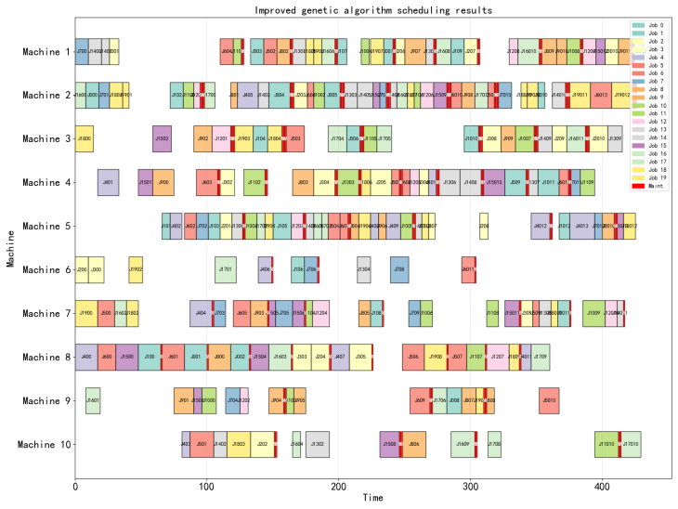
Figure 3 Gantt chart of the optimized MK9 schedule
The green and low-carbon constraints significantly affect scheduling performance. As illustrated in Figure 4, when the carbon emission limit becomes more stringent, both makespan and maintenance frequency increase notably, and job tardiness can rise sharply. For instance, with a carbon emission limit of 1.5, the maintenance frequency rises to 3 and tardiness reaches 75. In contrast, total carbon emissions remain relatively stable. These results demonstrate that the proposed approach effectively balances production efficiency and environmental objectives by adaptively coordinating maintenance and scheduling under different emission constraints.
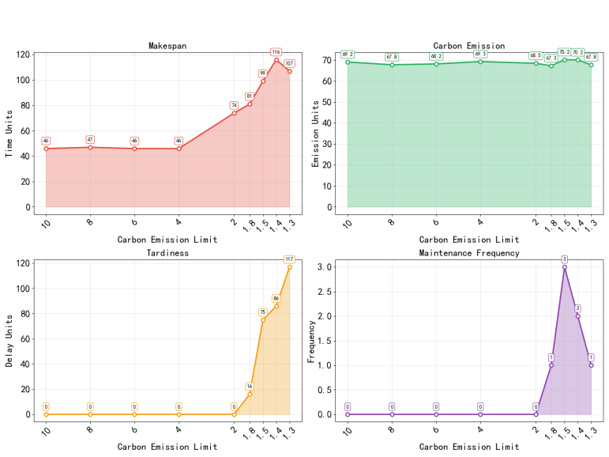
Figure 4 Performance metrics under varying carbon emission limits

Conclusions
This paper proposed an integrated optimization framework for green, low-carbon flexible job shop scheduling with preventive maintenance. By combining machine health management, carbon emission constraints, and data-driven parameter estimation, the model reflects practical shop-floor complexities. The Genetic Algorithm demonstrated robust scalability and solution quality, especially for large-scale cases where exact solvers failed. Results reveal that stricter carbon emission limits increase makespan and maintenance frequency, highlighting trade-offs between efficiency and sustainability. The proposed approach provides a practical tool for balancing productivity, equipment reliability, and environmental goals in modern manufacturing.
Future work may focus on adapting the proposed framework for real-time or dynamic scheduling environments and integrating more advanced artificial intelligence techniques for parameter estimation and decision-making. Further studies could also address uncertainties in production processes, evolving market demands, and the inclusion of additional sustainability metrics such as energy consumption and resource utilization.

References
- E. Nowicki and C. Smutnicki, “A fast taboo search algorithm for the job shop problem,” Management Science, vol. 42, no. 6, pp. 797–813, 1996.
- P.J.M. van Laarhoven and E.H.L. Aarts, “Simulated annealing: Theory and applications,” Annals of Operations Research, vol. 31, pp. 1–50, 1992.
- R. Zhang, C. Wu, and S. Wang, “A novel hybrid genetic algorithm for the job shop scheduling problem,” Computers & Operations Research, vol. 38, no. 1, pp. 91–99, 2011.
- J. Gao, L. Sun, and M. Gen, “A hybrid genetic and variable neighborhood descent algorithm for flexible job shop scheduling problems,” Computers & Operations Research, vol. 35, no. 9, pp. 2892–2907, 2008.
- K. Nonobe, T. Ibaraki, and M. Yagiura, “Formulation and exact algorithm for job shop scheduling problems with arbitrary processing times,” European Journal of Operational Research, vol. 264, no. 2, pp. 479–494, 2018.
- F. Luan, H.X. Zhao, S.Q. Liu, et al., “Enhanced NSGA-II for multi-objective energy-saving flexible job shop scheduling,” Sustainable Computing: Informatics and Systems, vol. 39, p. 100901, 2023.
- Z.X. Pan, D.M. Lei, and L. Wang, “A bi-population evolutionary algorithm with feedback for energy-efficient fuzzy flexible job shop scheduling,” IEEE Transactions on Systems, Man, and Cybernetics: Systems, vol. 52, no. 8, pp. 5295–530
- O. Benedikt, I. Módos, A. Novak, and Z. Hanzálek, "Green scheduling with time-of-use tariffs and machine states: Optimizing energy cost via branch-and-bound and bin packing strategies," European Journal of Operational Research, 2025. [Online]. Available: https://doi.org/10.1016/j.ejor.2025.06.026

